UJIAN AKHIR SEMESTER

Frame Work Mobile

Anggota Kelompok :

Danis Pangestu (165410156)

Dominikus Afendi Nahak (165410135)

Zaqie Alfatah (165410055)

Cuplikan code untuk akses data :

|  |
| --- |
| final NotesModel noteData;  final Function(NotesModel noteData) onTapAction;  @override  Widget build(BuildContext context) {  String neatDate = DateFormat.yMd().add_jm().format(noteData.date);  Color color = colorList.elementAt(noteData.title.length % colorList.length);  return Container(  margin: EdgeInsets.fromLTRB(10, 8, 10, 8),  height: 110,  decoration: BoxDecoration(  borderRadius: BorderRadius.circular(16),  boxShadow: [buildBoxShadow(color, context)],  ),  child: Material(  borderRadius: BorderRadius.circular(16),  clipBehavior: Clip.antiAlias,  color: Theme.of(context).dialogBackgroundColor,  child: InkWell(  borderRadius: BorderRadius.circular(16),  onTap: () {  onTapAction(noteData);  },  splashColor: color.withAlpha(20),  highlightColor: color.withAlpha(10),  child: Container(  padding: EdgeInsets.all(16),  child: Column(  crossAxisAlignment: CrossAxisAlignment.start,  children: <Widget>[  Text(  '${noteData.title.trim().length <= 20 ? noteData.title.trim() : noteData.title.trim().substring(0, 20) + '...'}',  style: TextStyle(  fontFamily: 'ZillaSlab',  fontSize: 20,  fontWeight: noteData.isImportant  ? FontWeight.w800  : FontWeight.normal),  ),  Container(  margin: EdgeInsets.only(top: 8),  child: Text(  '${noteData.content.trim().split('\n').first.length <= 30 ? noteData.content.trim().split('\n').first : noteData.content.trim().split('\n').first.substring(0, 30) + '...'}',  style:  TextStyle(fontSize: 14, color: Colors.grey.shade400),  ),  ),  Container(  margin: EdgeInsets.only(top: 14),  alignment: Alignment.centerRight,  child: Row(  children: <Widget>[  Icon(Icons.flag,  size: 16,  color: noteData.isImportant  ? color  : Colors.transparent),  Spacer(),  Text(  '$neatDate',  textAlign: TextAlign.right,  style: TextStyle(  fontSize: 12,  color: Colors.grey.shade300,  fontWeight: FontWeight.w500),  ),  ],  ),  )  ],  ),  ),  ),  ));  } |

|  |
| --- |
| void initState() {  super.initState();  NotesDatabaseService.db.init();  setNotesFromDB();  }  setNotesFromDB() async {  print("Entered setNotes");  var fetchedNotes = await NotesDatabaseService.db.getNotesFromDB();  setState(() {  notesList = fetchedNotes;  });  } |

Widget untuk menampilkan data :

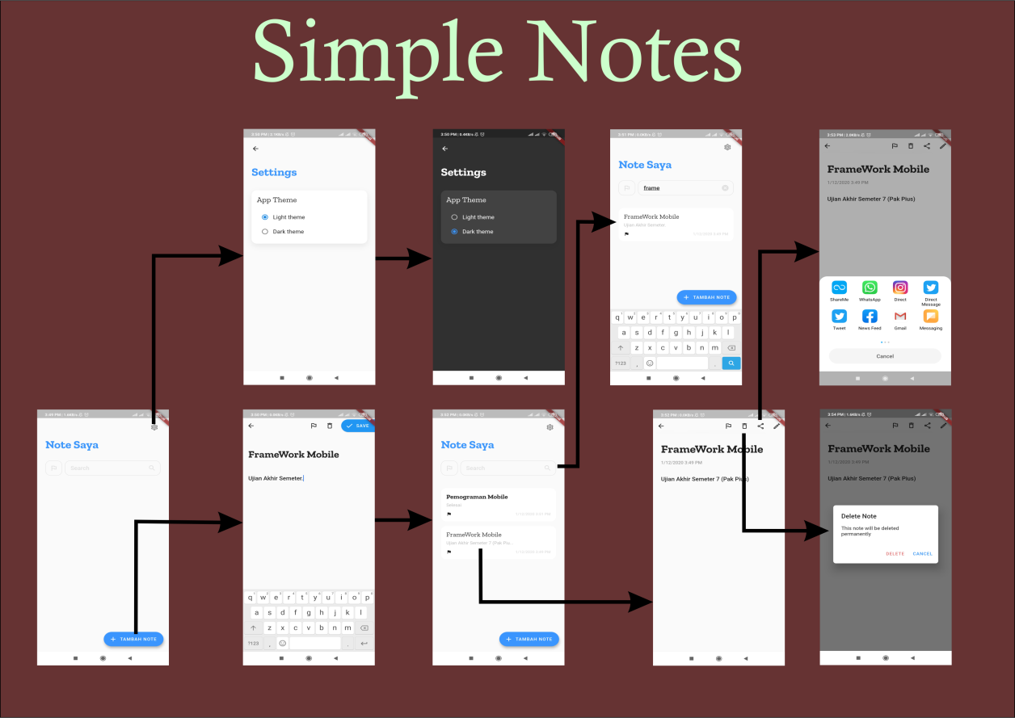

Widget tree

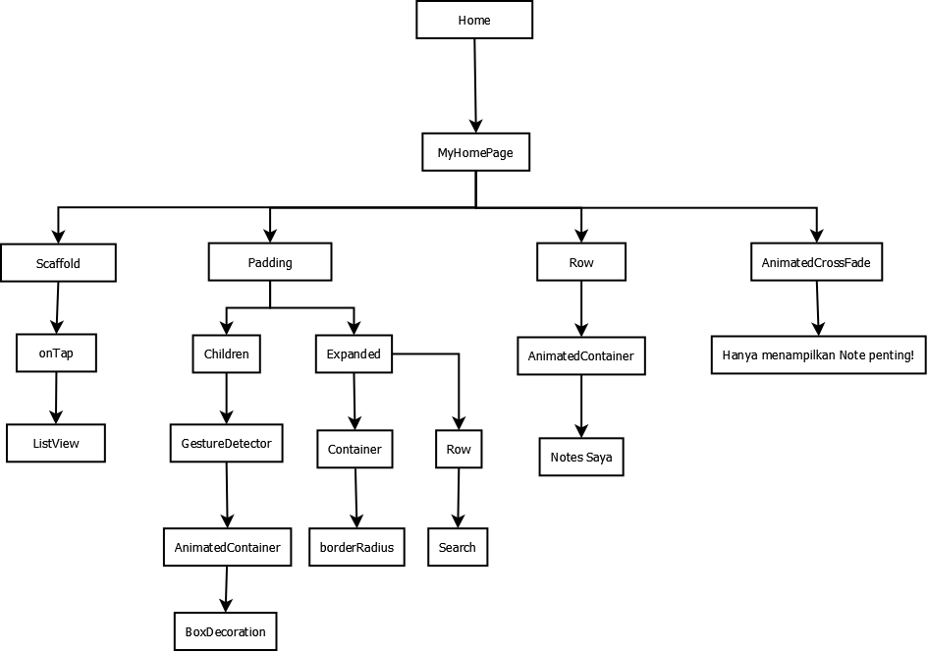

Layout Flow

